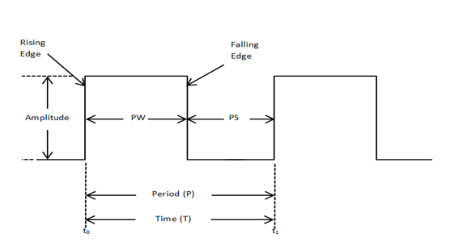**Components of a Pulse Waveform:**

* **Period** (P) or One Cycle is from one rising edge to the next rising edge.
* **Period** is equal to PW + PS
* **PW** (Pulse Width) also known as Time High/On, is measured at 50% of the waveform amplitude.
* **PS** (Pulse Space) also known as Time Low/Off, is measured at 50% of the waveform amplitude.
* **PRF** (Pulse Repetition Frequency), $PRF=$ $\frac{1}{Period}$
* **Duty Cycle**, $DC\%=\frac{PW}{Period}×100$
* An **Ideal Pulse Waveform** has perfectly vertical rising and falling edges and perfectly flat tops and bottoms.

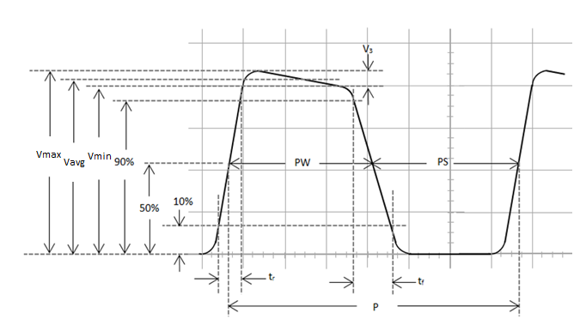**Pulse Waveform measurements:**

* **APA** (Average Pulse Amplitude), $APA=\frac{Vmax+Vmin}{2}$
* **Tilt, $Tilt\%=\frac{Vmax-Vmin}{APA}×100$**
* **Rise Time** tr, is defined as the time required for the voltage to go from 10% to 90% of the average amplitude.
* **Fall Time** tf**,** is defined as the time required for the voltage to go from 90% to 10% of the average amplitude.

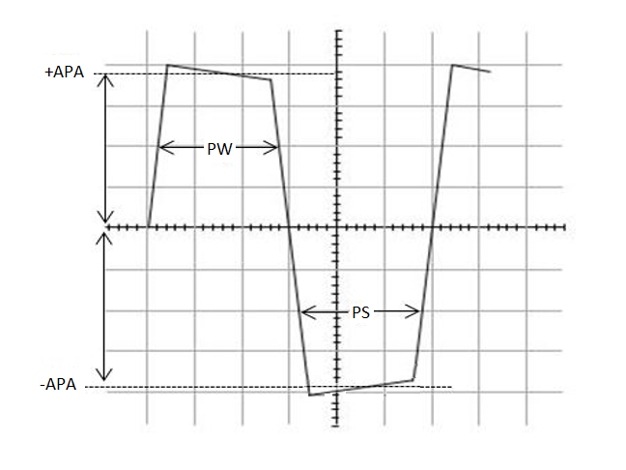**Average Waveform Voltage:**

If the Positive Peak and the Negative Peak are equal in amplitude and the Pulse Width and Pulse Space are also equal, we would observe the same amount of voltage above and below 0 for the same amount of time and the Average Waveform Voltage would be 0v. What if the Average Pulse Amplitude on the positive peak is different than the negative peak, or what if the Pulse Width is different than the Pulse Space, or both? How would you then find the Average Waveform Voltage be?

* **Average Waveform Voltage**, $AWV=\frac{(+APA×PW)+(-APA×PS)}{Period}$

**Average Waveform Voltage Example:**

* +APA = 8V
* -APA = -10V
* PW & PS = 50uS
* **Average Waveform Voltage**, $AWV=\frac{(+APA×PW)+(-APA×PS)}{Period}$
* **Average Waveform Voltage**, $AWV=\frac{(+8V×50uS)+(-10V×50uS)}{100uS}$
* **Average Waveform Voltage**, $AWV=\frac{(400×{10}^{-6})+(-500×{10}^{-6})}{100×{10}^{-6}}$
* **Average Waveform Voltage**, $AWV=\frac{-100×{10}^{-6}}{100×{10}^{-6}}$

$AWV=-1V$

**Average Waveform Voltage Example:**

* +APA = 8V
* -APA = -10V
* PW = 30uS
* PS = 10uS
* **Average Waveform Voltage**, $AWV=\frac{(+APA×PW)+(-APA×PS)}{Period}$
* **Average Waveform Voltage**, $AWV=\frac{(+8V×30uS)+(-10V×10uS)}{40uS}$
* **Average Waveform Voltage**, $AWV=\frac{(240×{10}^{-6})+(-100×{10}^{-6})}{40×{10}^{-6}}$
* **Average Waveform Voltage**, $AWV=\frac{140×{10}^{-6}}{40×{10}^{-6}}$

$AWV=3.5V$

**References**:

* Bell, D. A. (1997). *Solid state pulse circuits*. Sarnia, ON: David A. Bell.